Patient_Health_Monitoring_Portal Technical Design Document

|  |  |  |  |
| --- | --- | --- | --- |
|  | **Prepared By / Last Updated By** | **Reviewed By** | **Approved By** |
| **Name** |  |  |  |
| **Role** |  |  |  |
| **Signature** |  |  |  |
| **Date** |  |  |  |

|  |  |  |
| --- | --- | --- |
|  | **Table of Contents** |  |
| **1.0** | **Introduction** | **3** |
| **1.1** | **Purpose of this document** | **3** |
| **1.2** | **Project overview** | **3** |
| **2.0** | **Solution Summary** | **3** |
| **2.1** | **Scope** | **3** |
| **2.2** | **Assumptions** | **3** |
| **2.3** | **Dependencies** | **3** |
| **2.4** | **Risks** | **3** |
| **3.0** | **Schematic Diagram** | **3** |
| **4.0** | **System Design** | **4** |
| **4.1** | **Proposed design** | **4** |
| **4.2** | **Component inventory** | **4** |
| **5.0** | **Database Design** | **4** |
| **5.1** | **Data Model** | **4** |
| **5.2** | **Tables Structure** | **4** |
| **6.0** | **Appendices** | **4** |
| **6.1** | **Glossary** | **4** |
| **6.2** | **Other** | **5** |
| **7.0** | **Terms & Conditions** | **5** |
| **8.0** | **Change Log** | **5** |

# Introduction

## Purpose of this document

The purpose of this high level design document is to describe the detailed design of the Patient health monitoring portal application. All the components, annotations and interfaces used for the implementation of this project are mentioned here.

## Project overview

The aim of this project is to build a website and database for the doctor and patient. Doctors can able to view the health records of the patient and provide prescription and also they can able to view their appointments. Patient can able to suggest the doctor they need for appointment. Admin will book the appointment for patients depending on the suggestions given by the patients and also on the availability of doctors. Through this application we fix the appointments and make the patients relieve from travel stress.

# Solution Summary

## Scope

The scope of the detailed design document is to create and maintain the patient, doctor and admin details.

The login id and password for the patient, doctor and admin.

## Assumptions

Once the application is built, the login details for the admin is manually given in the database through which he can login.

The patient and doctor can be able to have their appointments only when the admin books for them.

.

## Dependencies

The Eclipse IDE is used for developing java applications. The maven is used to create the spring boot applications.

MySQL is used for the database operations.

The jsp file is used to create the web page that is shown in the browser. JDK 8 is necessary for execute the applications.

## Risks

The risk may be occured here is when multiple patient opt for the same doctor at a time, the doctor may not be available for the some patient rarely.

# 3.0 Schematic Diagram

A schematic, or schematic diagram, is a representation of the elements ofa [system](https://en.wikipedia.org/wiki/System) using abstract, graphic [symbols](https://en.wikipedia.org/wiki/Symbol) rather than realistic pictures. It gives an overview of overall system

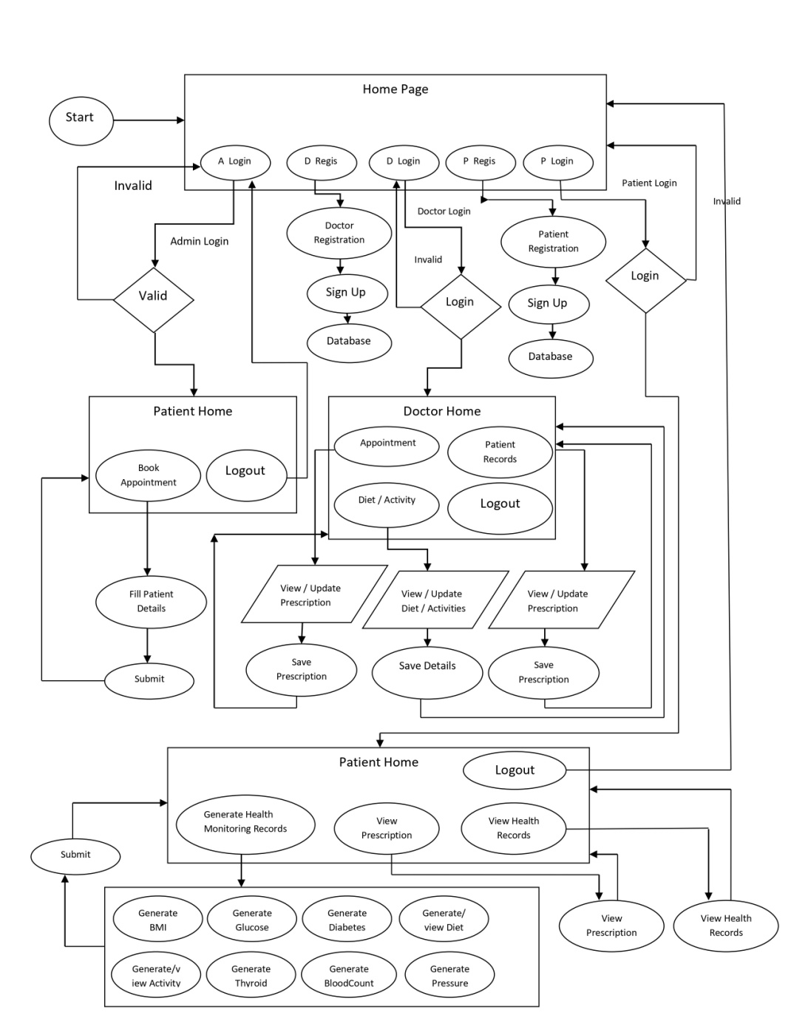

# System Design

## Proposed design

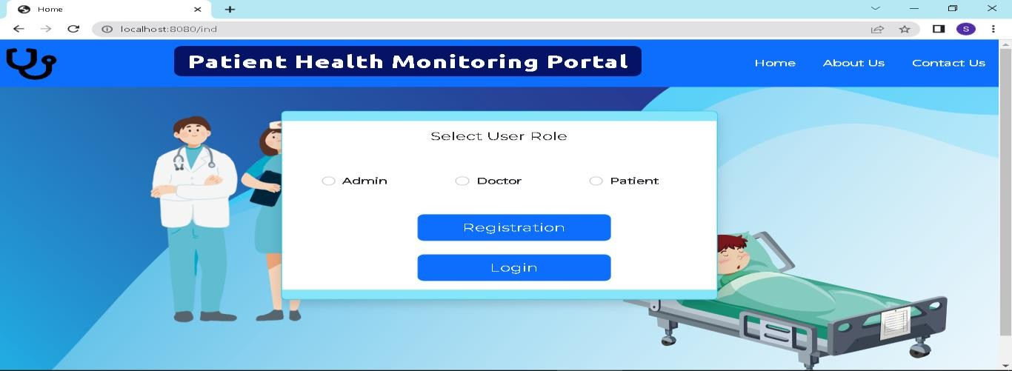

* 1. Component inventory

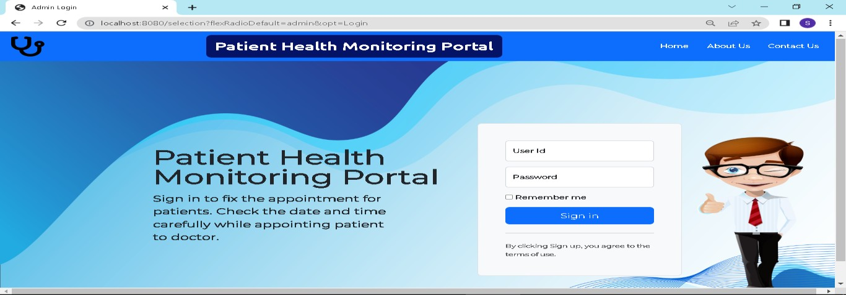

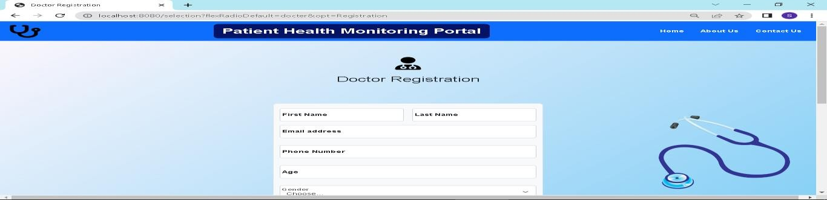

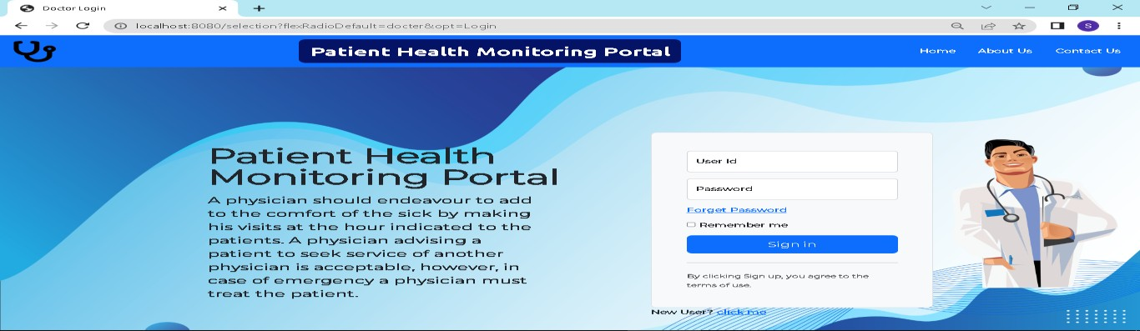

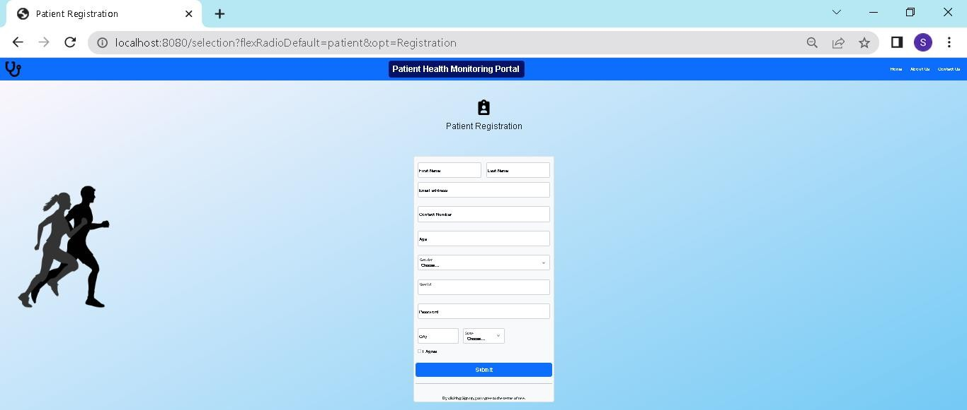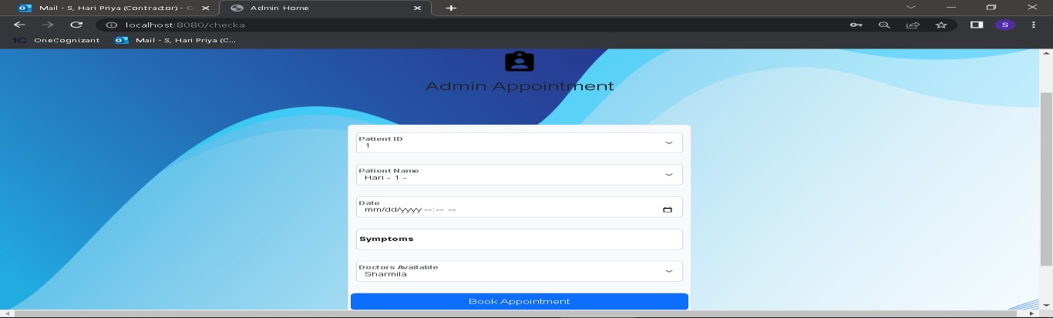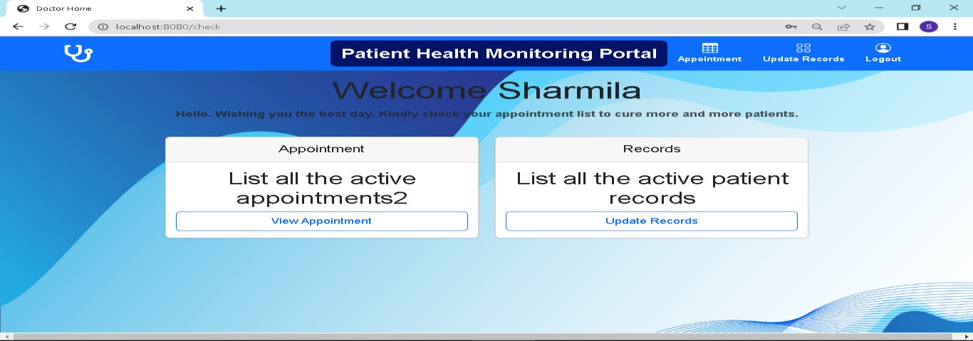

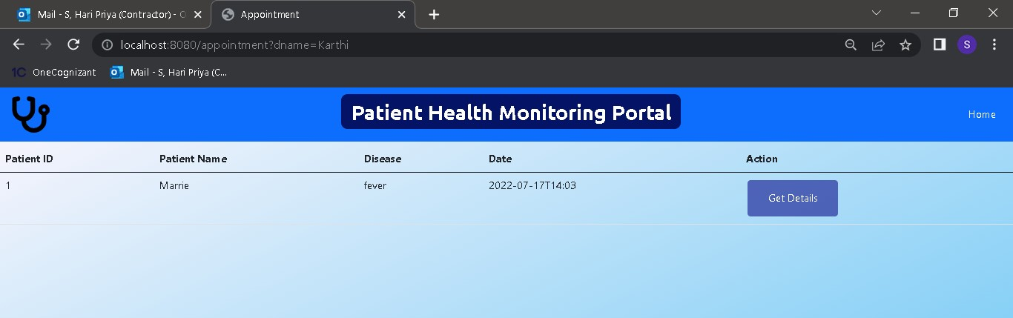

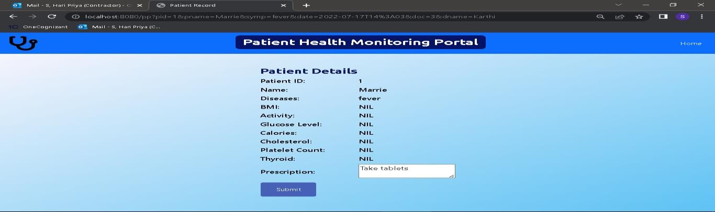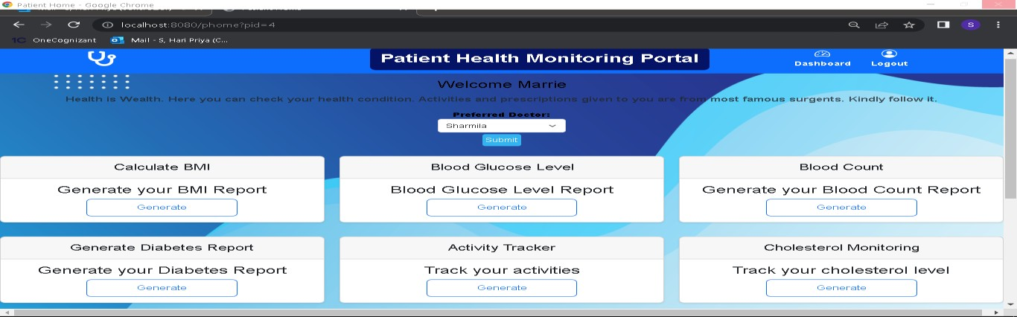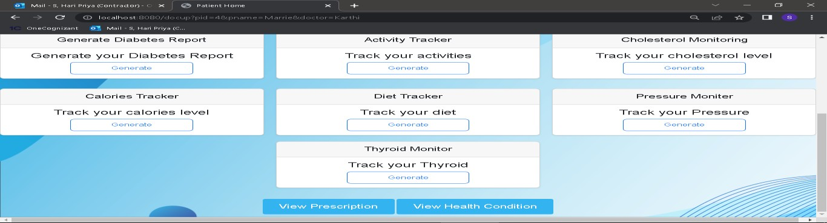

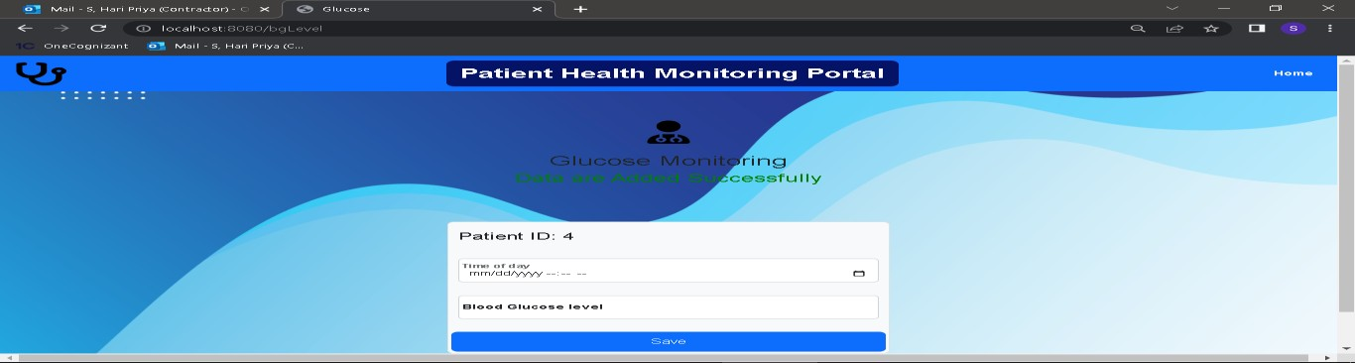

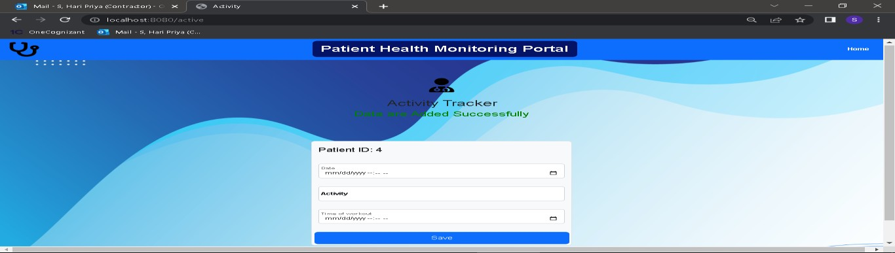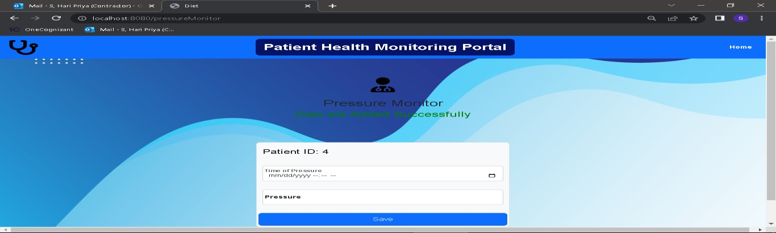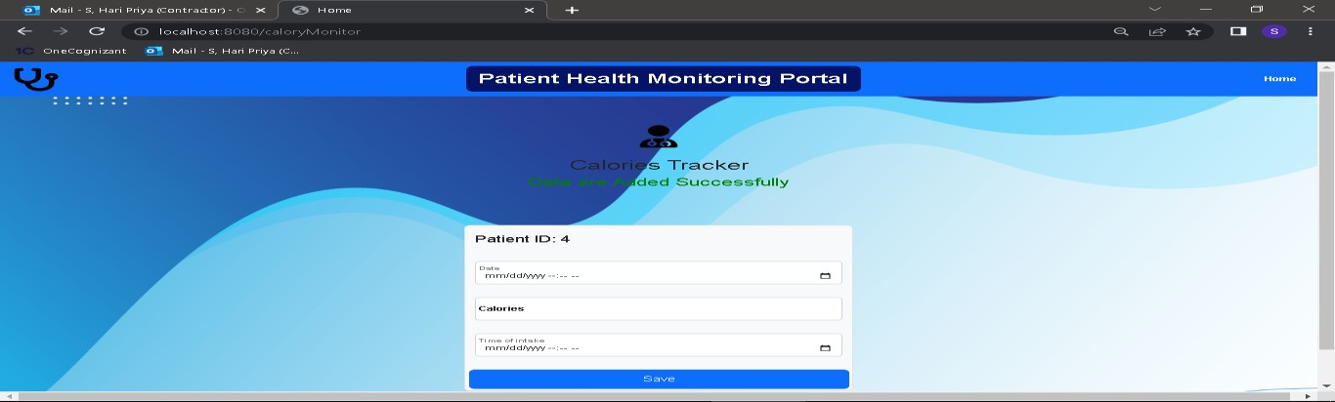

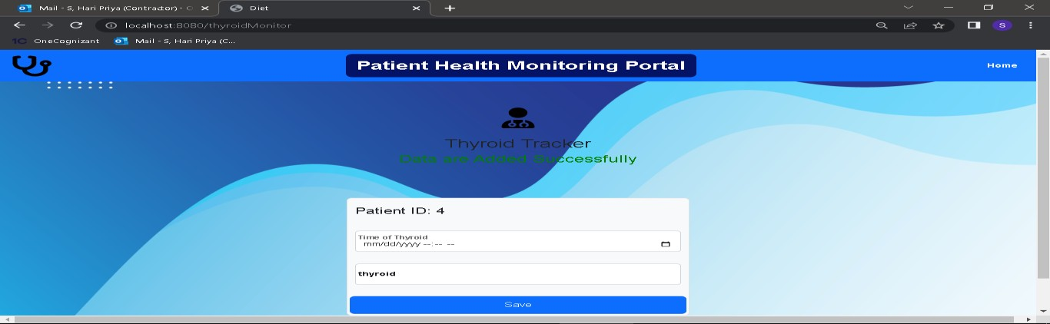

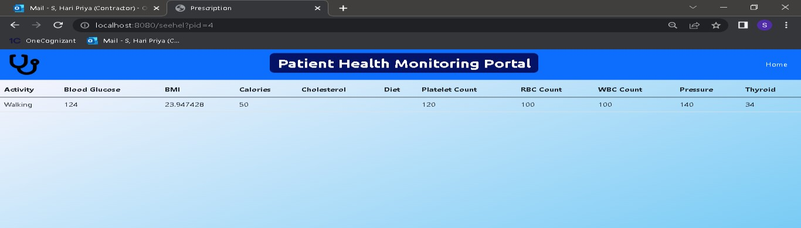

* 1. Database Design
  2. Data Model

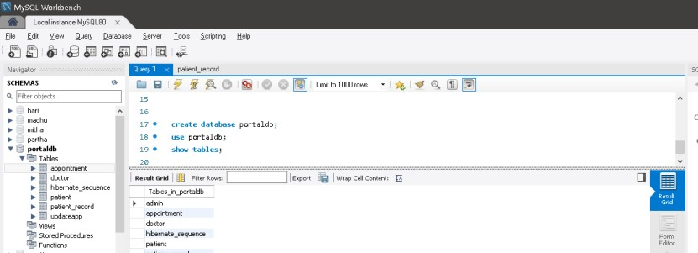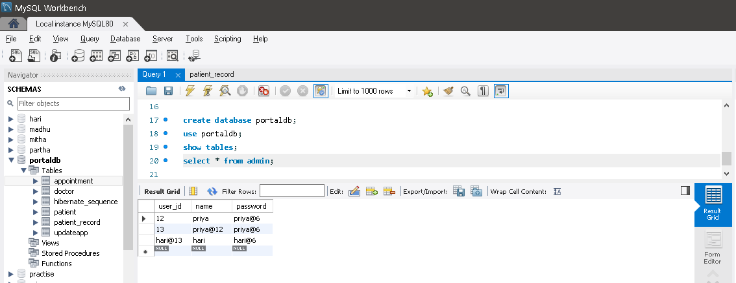

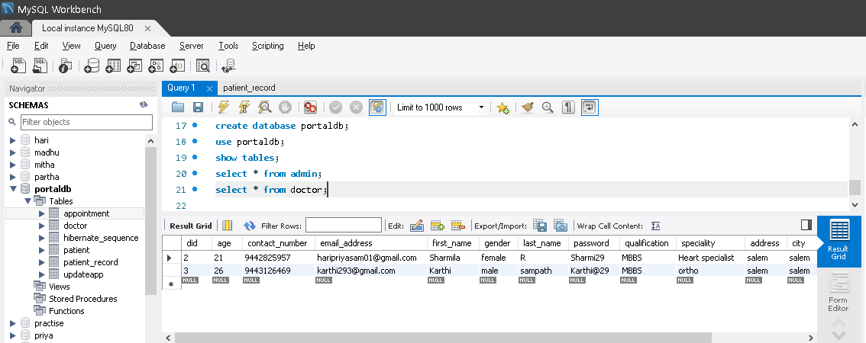

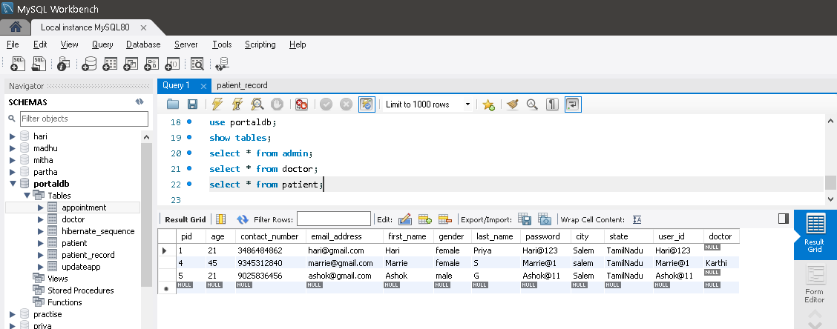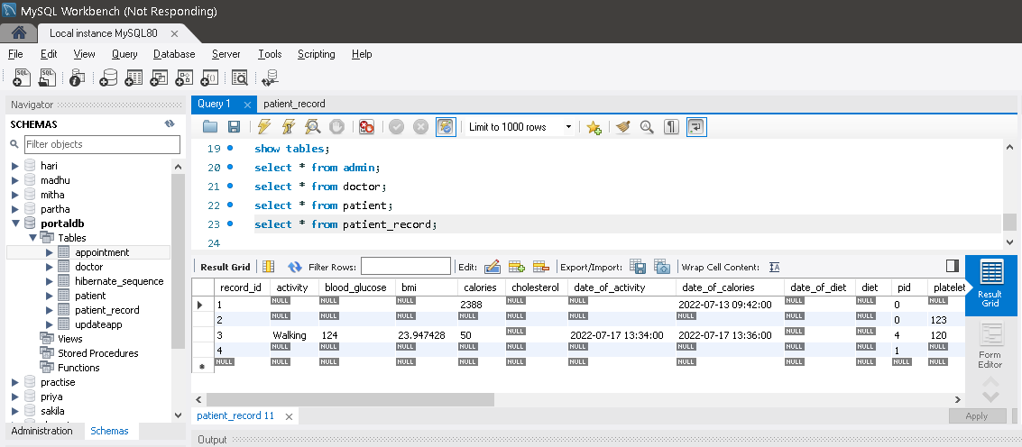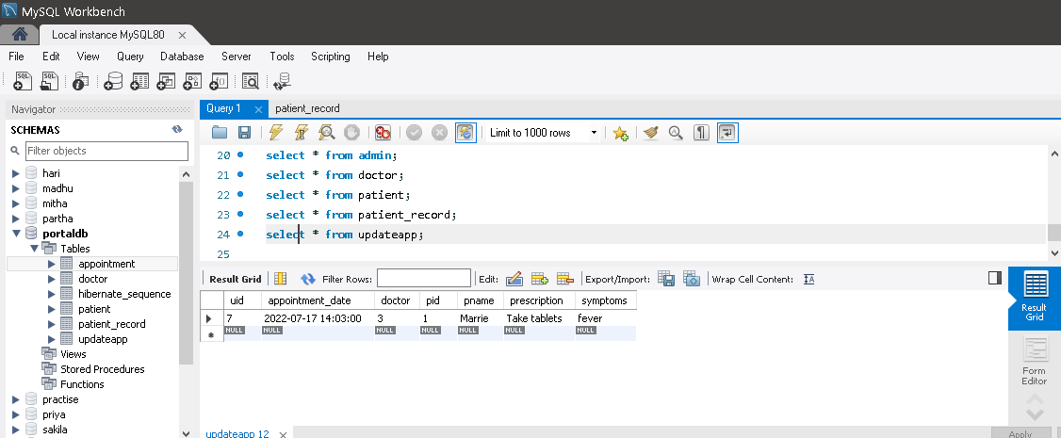

* 1. Tables Structure

|  |  |  |  |
| --- | --- | --- | --- |
| **Column Name** | **Data Type** | **Length** | **Nulls** |
| |  | | --- | | **adminid** | | name | | password | | |  | | --- | | varchar(255) PK | | varchar(20) | | varchar(64) | | Notspecified Notspecified Notspecified | Not Null Not Null Not Null |

|  |  |  |  |
| --- | --- | --- | --- |
| **Column Name** | **Data Type** | **Length** | **Nulls** |
| |  |  | | --- | --- | | **doc_id** |  | | doc_age |  | | **doc_email** |  | | doc_fname |  | | doc_gender |  | | doc_lname |  | | doc_password |  | | **doc_ph_no** |  | | doc_userid |  | | doc_sa1 |  | | doc_sa2 |  | | doc_sa3 |  | | doc_sq1 |  | | doc_sq2 |  | | doc_sq3 |  | | |  |  | | --- | --- | | bigint PK |  | | int |  | | varchar(255) |  | | varchar(255) |  | | varchar(255) |  | | varchar(255) |  | | varchar(255) |  | | bigint |  | | varchar(255) |  | | varchar(255) |  | | varchar(255) |  | | varchar(255) |  | | varchar(255) |  | | varchar(255) |  | | varchar(255) |  | | Notspecified Notspecified Notspecified  Notspecified Notspecified Notspecified  Notspecified Notspecified Notspecified  Notspecified Notspecified  Notspecified Notspecified  Notspecified Notspecified Notspecified  Notspecified Notspecified | Not Null Not Null Not Null  Not Null Not Null Not Null  Not Null Not Null Not Null  Not Null Not Null  Not Null  Not Null Not Null Not Null  Not Null Not Null Not Null |

|  |  |  |  |
| --- | --- | --- | --- |
| **Column Name** | **Data Type** | **Length** | **Nulls** |
| |  |  | | --- | --- | | patient_id |  | | patient_age |  | | patient_city |  | | patient_email |  | | patient_fname |  | | patient_gender |  | | patient_lname |  | | patient_password |  | | patient_ph_no |  | | patient_user_id |  | | pa_sa1 |  | | pa_sa2 |  | | pa_sa3 |  | | pa_sq1 |  | | pa_sq2 |  | | pa_sq3 |  | | |  |  | | --- | --- | | bigint PK |  | | int |  | | varchar(255) |  | | varchar(255) |  | | varchar(255) |  | | varchar(255) |  | | varchar(255) |  | | varchar(255) |  | | Bigint |  | | varchar(255) |  | | varchar(255) |  | | varchar(255) |  | | varchar(255) |  | | varchar(255) |  | | varchar(255) |  | | varchar(255) |  | | Notspecified Notspecified Notspecified  Notspecified  Notspecified  Notspecified  Notspecified  Notspecified  Notspecified  Notspecified  Notspecified  Notspecified Notspecified  Notspecified Notspecified Notspecified  Notspecified Notspecified | Not Null Not Null Not Null  Not Null  Not Null  Not Null  Not Null  Not Null  Not Null  Not Null  Not Null  Not Null  Not Null Not Null Not Null  Not Null Not Null Not Null |

* 1. Appendices
  2. Glossary

|  |  |
| --- | --- |
| **Acronyms** | **Definitions** |
| appid pid pname did  u_id | Appointment_id Patient_id Patient name Doctor_id  User_id |

* 1. Other

7.0 Terms & Conditions

***Disclaimer: Please do not circulate or distribute this document outside of Cognizant Network, We have a Zero Tolerance Policy. Kindly adhere to 100% Compliance at all times.***

# 8.0 Change Log

*Please note that this table needs to be maintained even if a Configuration Management tool is used.*

|  |  |  |  |  |
| --- | --- | --- | --- | --- |
| **Version Number** | **Changes made** | | | |
| V<n.n> | *<If the change details are not explicitly documented in the table below, reference should be provided here>* | | | |
| Page no | Changed by | Effective date | Changes effected |
|  |  |  |  |
|  |  |  |  |
|  |  |  |  |
|  |  |  |  |